White Lily Casino

**Objective**

To show how likely it is to lose your money at a casino and how it affects your personal life.

**Description**

This program will be a virtual casino in first person with the option to play ; blackjack, three-card monte, odd or even, over or under, or slots[1].

The user begins with a certain amount of money. (Their progress is saved using file IO) The goal is to walk away from the casino with more money than you started with. There will be multiple storylines; having a wife and kids, being single and tight on money, being a rich child with gambling problems, being a gambling addict, or being a financially struggling student who wants to gamble to pay post-secondary tuition and eventually buy a house.

[1] - I will add this feature if I have time

**User Interface**

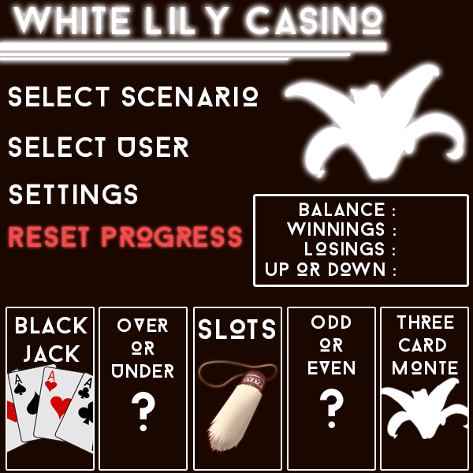

**Design**

|  |
| --- |
| **Casino** |
| -balance : int  -winnings : int  -losings : int |
| + deal() : void  +getBalance() : int  +getWinnings() : int  +getLosings() : int  +addWinings(int winnings) : void  +addLosings(int losings) : void  +setBalance(int balance) : void |

|  |
| --- |
| **Card** |
| -cardValues : int[]  -value : int  -cardID : String |
| +getRandomCard() : Card  +getValue() : int  +getcardID() : String  +setValue(int value) : void  +setCardID(String cardID) : void |

|  |
| --- |
| **Deck** |
| -numCards : int  -cards : ArrayList<Card> |
| +shuffle() : void  +addCard(Card card) : void  +removeCard(Card card) : void  +reset() : void |

|  |
| --- |
| **Player** |
| -accountBalance : int  -startingAccountBalance : int  -winnings : int  -losings : int  -scenario : String  -playerName : String |
| +resetProgress() : void  +isOutOfMoney() : boolean  +isUpOrDown() : String  +setScenario(String scenario) : void  +setStartingBalance(int balance) : void  +getWinnings() : int  +getLosings() : int  +setName(String name) : void  +getName() : String |

|  |
| --- |
| **Blackjack** extends **Casino** |
| -turns : int  -winLossRatio : int |
| +hit() : void  +stay() : void  +getWinLossRatio() : int  +getTurns() : int  +start() : void  +end() : void |

|  |
| --- |
| **ThreeCardMonte** extends **Casino** |
| -winLossRatio : int  -cards : ArrayList<Card>  -correctCard : Card |
| +guess(int card) : void  +getWinLossRatio() : int  +start() : void  +end() : void |

|  |
| --- |
| **OddOrEven** extends **Casino** |
| -winLossRatio : int  -number : int |
| -isOdd() : boolean  -isEven() : boolean  +guess(String oOrE) : void  +getWinLossRatio() : int  +start() : void  +end() : void |

|  |
| --- |
| **OverOrUnder** extends **Casino** |
| -winLossRatio : int  -number : int |
| -isOver() : boolean  -isUnder() : boolean  +guess(String oOrU) : void  +getWinLossRatio() : int  +start() : void  +end() : void |